Ideation Phase

Empathize & Discover
Date | 19 September 2026
Team ID | Shaik Irshad – 238W1A4256
Project Name | Automated Network Request Management in ServiceNow
Maximum Marks | 4 Marks

Empathy Map Canvas
An empathy map is a simple, easy-to-digest visual that captures knowledge about a user's behaviours and attitudes. It helps the project team understand the person who submits a network service request before designing the ServiceNow solution.
For this project, the map is built around the primary actor of the Network Request process — the Requester (an employee who needs to raise a network-related service request through the ServiceNow Service Portal). It reflects the problem context described in the project's problem statement and is used for ideation purposes only; it is not the output of a formal, separate user-research study.
Persona: Employee / Requester submitting a Network Request
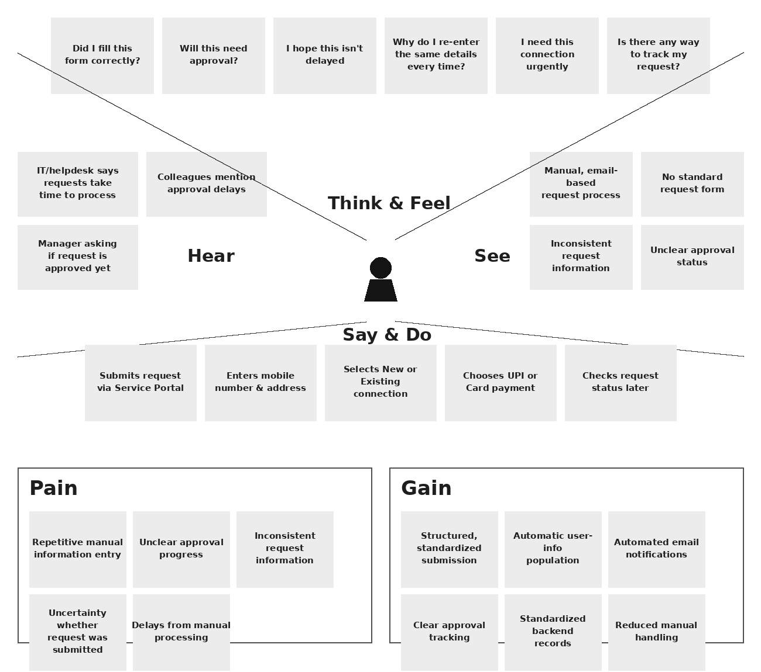

Note: The Pains and Gains identified above directly correspond to the problem statement and objectives of the Network Request ServiceNow implementation — the automated workflow was designed specifically to remove these pains and deliver these gains.

